Holiday Pie Sales
(cheesecake and cookies as well)

Sponsored by Richfield Township
Downtown Development Authority

On the order form please write your name and phone number at the top and circle your choices, indicating if more than one of any item is ordered. Your order must be turned in no later than Wednesday November 7th.

Turn the order form and money into BS Liquor,
Richfield Township Offices or St. Helen Hardware
If paying by check make check payable to:
Richfield Township D.D.A.

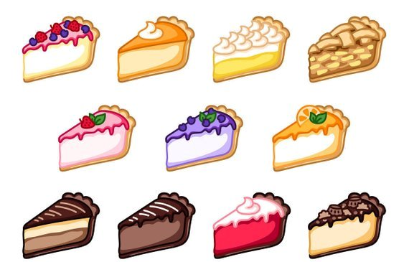
Orders will be picked up by bs liquor from Gordon food service and brought back to st. Helen on November 15th. They will be frozen and You will get called late that afternoon or evening to advise your order is in and it can be picked up—so it is important that you provide a telephone number on your order.

